Project Design Phase-II Technology Stack (Architecture & Stack)

PNT2022TMID35987

2022

|  |  |
| --- | --- |
| Date | 28 October2022 |
| Team ID | PNT2022TMID41150 |
| Project Name | Project - Personal Expense Tracker |
| Maximum Marks | 4 Marks |

# Technical Architecture:

The Deliverable shall include the architectural diagram as below and the information as per the table1 & table 2

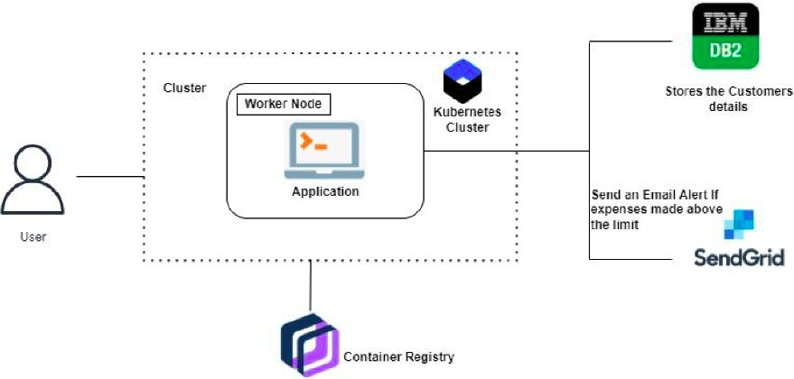

# Table-1 : Components & Technologies:

|  |  |  |  |
| --- | --- | --- | --- |
| **S.No** | **Component** | **Description** | **Technology** |
| 1. | User Interface | How user interacts with application e.g. Web UI, Mobile App, Chatbot etc. | HTML, CSS, JavaScript in Python Flask |
| 2. | User Login | The user can login either through their gmail account or an account in the app server | Google Oauth for Google Signin. Hashed password in DB |
| 3. | Graph Visualisation | Rendering plots and graphs based on the user spending data | Seaborn, Mathplotlib |
| 4. | Database | Data Type, Configurations etc. | NoSQL database can be used as it  promotes flexible structuring of data |
| 5. | Cloud Database | Database Service on Cloud | IBM DB2 is used to store the user details and the data entries |
| 6. | SendGrid | a cloud-based SMTP provider that allows you to send email without having to maintain email servers | SendGrid is used to trigger mail to user emails when a particular condition is met |
| 7. | Google OAuth | OAuth 2.0 allows users to share specific data with an application while keeping their usernames, passwords, and other information private. | Enables login through gmail account, thus making the application accessible |
| 8. | Cloud Deployment | Application Deployment onCloud Server | Docker and Kubernetes is used for deployment as it promises scalability and high availability |

**Table-2: Application Characteristics:**

|  |  |  |  |
| --- | --- | --- | --- |
| **S.No** | **Characteristics** | **Description** | **Technology** |
| 1. | Open-Source Frameworks | Flask is a micro web framework written in Python. It is classified as a microframework because it does not require particular tools or libraries. | Python Flask Framework |
| 2. | Security Implementations | Passwords cant be stored as plaintext so it is hashed and salted | BCrypt |
| 3. | Scalable Architecture | Containerized application is deployed to rapidly increase scale on demand | Docker |

|  |  |  |  |
| --- | --- | --- | --- |
| **S.No** | **Characteristics** | **Description** | **Technology** |
| 4. | Availability, Performance | Kubernetes is an open-source container orchestration system for automating software deployment, scaling, and management.  Availability and Performance enhances user experience | Kubernetes |